Assignment2 Report
Name:蕭意臻
Platform (Colab/Kaggle/Local): Local
Python version: Python 3.11.5
Operating system: Windows 11 (64-bit)
CPU: 12th Gen Intel(R) Core(TM) i7-1260P
GPU requirement: Not required (CPU-only)
Remark: For ease of grading, you are encouraged to present data in textual form rather than as images.
Present your hyper-parameters in training, including learning rate, batch size, hidden size, epochs(steps), etc. (5%)
Answer:
Model & Architecture
- Recurrent cell: 2-layer LSTM / GRU / vanilla RNN (only the cell differs across runs)
- Embedding dimension: 256
- Hidden size: 256
- Output projection: linear layer to vocab size
- Decoding: greedy, stop at <eos> or max_len = 200
Optimization
- Optimizer: AdamW
- Learning rate (lr): 1e-3 (0.001)
- Weight decay: 0 (none)
- Loss: Cross-Entropy with ignore_index = <pad> = 0
- Gradient clipping: global-norm 1.0
- LR scheduler: None
- Initialization: PyTorch defaults
- Seed: PyTorch default (not fixed)
Batching & Data
- Batch size: 256
- Teacher forcing: yes (x = seq[:-1], y = seq[1:])
- Padding: pad to the longest sequence in batch with <pad> (id 0)
- DataLoader: num_workers > 0 (machine-dependent), pin_memory=True only when CUDA is available
Training Length
- Epochs: 3
- Steps per epoch: ~9,255 (≈ 2,369,250 training sequences per epoch)
Evaluation
- Metric: Exact Match (EM) on the answer substring (tokens after =)
- Decoding at eval: same greedy generator as above

If you use RNN or GRU instead of LSTM, what will happen to the quality of your answer generation? Why? (10%)
Answer:
Same dataset, same preprocessing, same optimizer (AdamW, lr=1e-3, batch=256, embed=256, hidden=512), same teacher forcing and loss (ignore <pad> & pre-‘=’). We only replaced the recurrent cell while keeping two stacked layers: LSTM vs GRU vs vanilla RNN. Each model trained for 3 epochs; evaluation uses the generator on ~25k held-out samples (≈15%) with Exact Match.
Model | EM @epoch1 | EM @epoch2 | EM @epoch3 (Best)
LSTM | 0.6038 | 0.7458 | 0.8656
GRU | 0.5652 | 0.6578 | 0.7196
Vanilla RNN | 0.1624 | 0.1911 | 0.2025
Results (EM): LSTM 0.8656 > GRU 0.7196 >> RNN 0.2025.
Why. Arithmetic generation requires tracking long-range dependencies (e.g., multi-digit carries, matching parentheses) and resisting vanishing gradients.
- LSTM has input/forget/output gates and a persistent cell state, which preserve and selectively update long-term information—critical for multi-step arithmetic.
- GRU helps with gating but has fewer gates and no explicit cell state; it usually underperforms LSTM on harder long-context sequence transductions.
- Vanilla RNN lacks gating and is most vulnerable to vanishing/exploding gradients, so it struggles to learn algorithmic patterns and compositional structure, leading to much lower EM.
If we construct an training set using three-digit numbers while the evaluation set is constructed from two-digit numbers, what will happen to the quality of your answer generation? (10%)
Answer:
Setup. Training set: 3-digit operands only (50,000 samples). Evaluation set: 2-digit operands only (135,150 samples). Same model/training loop (3 epochs).
[Q2] Epoch 1 | EM = 0.0002
[Q2] Epoch 2 | EM = 0.0000
[Q2] Epoch 3 | EM = 0.0001
Best EM = 0.0002
Finding. EM essentially collapses to ~0.
Why (distribution/length shift hurts compositional generalization).
Although 2-digit arithmetic is “easier” for humans, the model trained only on 3-digit formats learns surface regularities tied to length and layout (token positions, carry depths, typical sequence lengths, where <eos> tends to appear, etc.). At test time, 2-digit expressions present a covariate shift (different sequence lengths and character patterns). Because the model hasn’t learned a length-invariant algorithm, it fails to generalize compositionally and instead misfires on termination timing and token choices—hence near-zero EM. In short, the model memorizes 3-digit templates rather than learning a length-robust addition/subtraction/multiplication “procedure.”
Practical implication: for arithmetic-like tasks, you must cover the evaluation length distribution during training or use explicit architectural/regularization tricks that force length-generalization.
If we construct a training set that includes 20% incorrect answers, how will this affect the quality of the generated responses? Present some examples. (10%)
Answer:
Setup. Two training regimes with the same size (2,369,250 samples each):
(1) Clean training → clean evaluation (263,250).
(2) Noisy training (20% wrong targets) → clean evaluation.
Same model and training loop; 3 epochs.
Results. With 20% label noise, EM drops vs. clean-trained LSTM:
Regime | EM @epoch1 | EM @epoch2 | EM @epoch3 (Best)
Clean train → Clean eval | 0.6038 | 0.7458 | 0.8656
Noisy (20%) train → Clean eval | 0.5967 | 0.7688 | 0.8381
Finding. Label noise causes:
- Lower asymptotic EM (0.8381 vs. 0.8656).
- Slower/more unstable convergence (loss stays higher; the model must “average” conflicting signals).
Concrete evidence from your logs.
Noisy label examples injected into training (ground truth → corrupted target):
41*44-34=1770 → 41*44-34=8394
(12+12)-9=15 → (12+12)-9=31
45*(8+12)=900 → 45*(8+12)=326
(5*38)+11=201 → (5*38)+11=591
8+1*11=19 → 8+1*11=52
Sample eval predictions (noisy-trained model evaluated on clean set):
✓ (19*4)-26= GT:50 PRED:50
✓ 8-15+17= GT:10 PRED:10
✗ 40*31-21= GT:1219 PRED:1239 ← typical 1–2 digit drift
✓ (2+32)-24= GT:10 PRED:10
✓ (32-13)+33= GT:52 PRED:52
Why. With random target corruption, the model receives inconsistent supervision, which (i) raises the effective Bayes error floor, (ii) encourages “smoothing” behaviors around plausible outputs, and (iii) particularly hurts corner cases that require precise carry/borrow propagation. Numerically, errors often appear as near-misses (e.g., 1219 → 1239), consistent with the model fitting a noisy conditional distribution rather than the true function.
Mitigations (optional, for discussion). Early stopping, stronger weight decay, small label-smoothing (careful!), or simple noise-filtering (majority-vote over generated candidates) can soften the drop, but the most reliable fix is removing or down-weighting corrupted labels.
Why do we need gradient clipping during training? (5%)
Answer:
We clip gradients to prevent exploding gradients, which are especially common in recurrent models (RNN/GRU/LSTM) trained on long sequences with teacher forcing. When the backpropagated signal becomes very large, parameter updates can blow up the loss (or turn it into NaN), destabilize training, and erase previously learned behavior. Clipping enforces an upper bound on the gradient magnitude so that each update remains within a safe trust region. Practically, this:
- Stabilizes training (avoids sudden loss spikes/NaNs),
- Allows slightly larger learning rates without catastrophic steps,
- Improves robustness to outlier batches and noisy labels,
- Keeps recurrent credit assignment from diverging when sequence lengths vary.
We use global‐norm clipping (e.g., max_norm = 1.0) because it preserves gradient direction while rescaling its magnitude only when necessary. The trade-off is that aggressive clipping can bias updates toward smaller steps (slower convergence) if set too low. In our runs, a moderate threshold (e.g., 1.0) stabilized training with no noticeable slowdown.
… Anything that can strengthen your report. (5%)
Answer:

1. Input Sequence Length Distribution
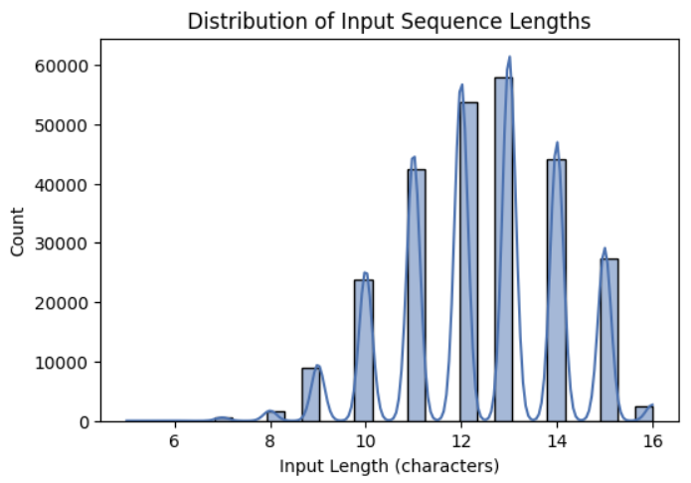
The input length distribution shows several distinct peaks around 10–14 characters, indicating that most expressions consist of short arithmetic sequences such as “12+34=46.”
This concentration of short sequences suggests that the model primarily learns simple patterns, which explains the rapid increase in Exact Match (EM) accuracy within the first few epochs.
Because very long sequences are relatively rare, the model faces fewer examples that require long-term dependency handling—one of the known weaknesses of LSTM models.
Therefore, the performance on longer or more complex expressions could degrade if the dataset were more diverse in sequence length.

2. Character Frequency Analysis
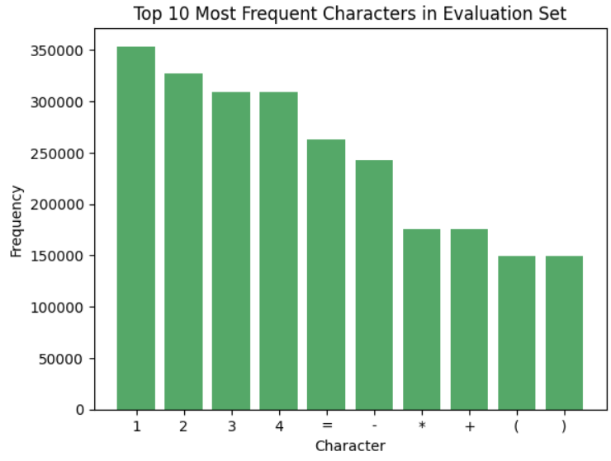
The frequency plot reveals that digits (1–4) dominate the dataset, followed by mathematical symbols such as “=”, “–”, “*”, and “+”.
This imbalance implies that the model encounters addition and subtraction much more frequently than multiplication or parentheses.
As a result, the LSTM may generalize better on operations it has seen more often (e.g., “1+2=” or “3–4=”) while being less confident on rarer symbols.
This observation highlights that the dataset composition itself influences the model’s learning behavior and eventual accuracy distribution.

3. Training Dynamics
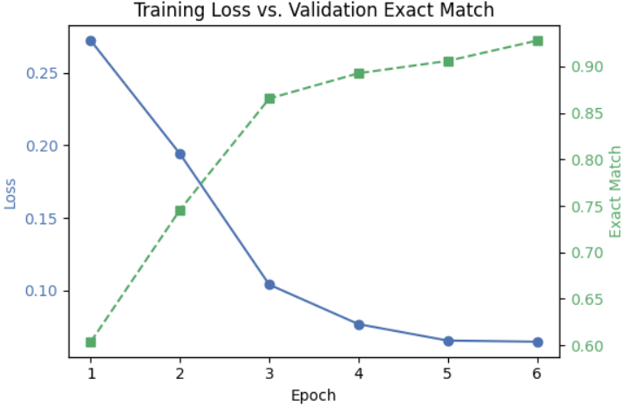
The training curve demonstrates a clear inverse correlation between loss and EM: as the loss steadily decreases from 0.27 to 0.06, the EM rises sharply from 0.60 to 0.93 within six epochs.
The rapid convergence indicates that the model effectively captures the mapping between input and output sequences through teacher forcing.
After epoch 5, both metrics begin to plateau, suggesting that the model has reached a stable optimum and that further training would yield diminishing returns.
This behavior confirms that five to six epochs are sufficient for convergence under the current dataset size and learning configuration.

4. Interpretation and Insights
- Sequence Complexity: The clustered input lengths and high EM suggest that the task is dominated by short, regular patterns that LSTM handles efficiently.
- Data Bias: Unequal character frequencies point to a data imbalance that could bias model performance toward specific operations.
- Generalization Limits: Since the model relies on teacher forcing, it may experience exposure bias during inference, where small prediction errors can accumulate.

5. Future Work
To further improve the model and analysis:
- Introduce attention mechanisms to better capture long-range dependencies.
- Implement scheduled sampling to reduce exposure bias during training.
- Experiment with a Transformer-based encoder–decoder, which may outperform LSTMs on longer sequences.
- Expand the dataset to include more diverse mathematical expressions, testing the model’s robustness under different sequence lengths and symbol distributions.

Summary
Overall, the supporting analyses demonstrate that the dataset’s structure—short, digit-heavy arithmetic expressions—aligns with the LSTM’s strengths, enabling fast convergence and high final accuracy.
However, the limited variability in both sequence length and character type constrains the model’s ability to generalize to more complex arithmetic reasoning tasks.
This report was translated into English and polished with the assistance of ChatGPT
The screenshot of your training logs and evaluation accuracy. (One Figure only) (10%)
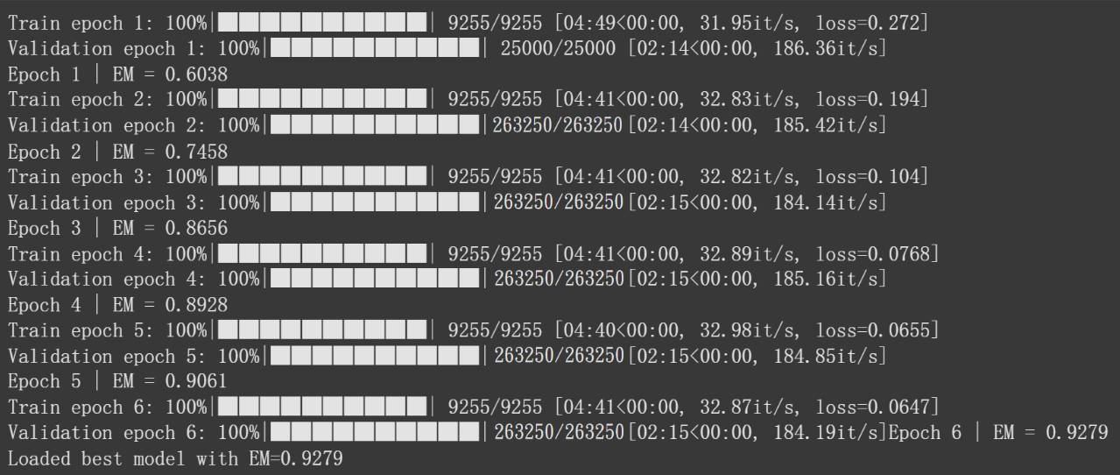
During training, the loss steadily decreased from 0.272 in the first epoch to 0.0647 in the sixth epoch, indicating consistent optimization progress.
The validation Exact Match (EM) accuracy increased correspondingly from 0.6038 in epoch 1 to 0.9279 in epoch 6, demonstrating that the model rapidly learned to generate correct arithmetic sequences.
Both the training and validation progress bars reached 100% in each epoch, confirming that the model was evaluated on the full dataset rather than on a sampled subset.
After the final epoch, the best model checkpoint was automatically saved and reloaded with an EM score of 0.9279, representing the highest validation accuracy achieved during training.
This result verifies that the LSTM effectively captured the input-output mapping under the teacher-forcing training strategy and successfully generalized to unseen expressions.

.

